Waterhole
The origin of my SETI station can be traced directly to a book edited by Carl Sagan in 1973 called Communication with Extraterrestrial Intelligence (CETI). In one of the papers in this collection of papers, Bernard M. Oliver from Ames Research, described project Cyclops and cited a paper by Cocconi and Morrison in a 1959 paper in Nature. This paper suggested the use of the hydrogen line at 1420 megahertz as the natural frequency on which to search for beacons.
On page 280 of CETI Oliver said “It is important to realize that microwaves are superior for fundamental reasoned, not just because they represent a more mature art.”
He went on to list the following reasons:
- Galactic noise (synchrotron radiation) at a minimum
- Thermal noise (receiver and isotropic background noise) at a minimum
- Quantum noise (spontaneous emissions or shot noise) at low level
- Star noise at a low level
He presented these findings in an iconic image of what is called the Water hole – the preferred interstellar radio communications channel.
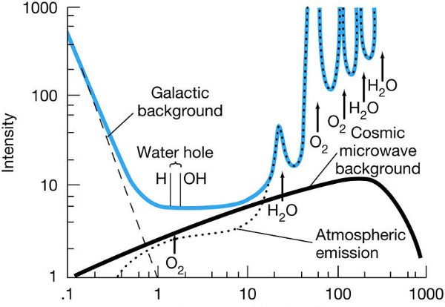
Figure 1 Waterhole
The minimum noise lies between 1 and 2 GHz where the hydrogen (21 cm or 1420 MHz) and the hydroxyl (18 cm or 1662 MHz) lines reside.
Oliver then went on to point out that the preferred search area cannot be narrowed down for technical reasons to be any less that between 1420 and 1662 MHz there are other rather romantic or poetic ways to narrow it down. The 242 MHz area between the hydrogen line and the hydroxyl line are the quietest part of the spectrum and that there are no other known spectral lines. He says:
“What more poetic place could there be for water-based life to seek its kind than the age-old meeting place for all species: the water hole:
To this list of reasons to search the water hole I add the following:
Dish – After about 1980 a large number of L-Band antennas became available when the switch to cable distribution of TV signals was made and the move to higher bands for satellite to Earth (DirecTV) transmissions was completed. These TV Receive Only (TVRO) dishes can be purchased for a fraction of the price when new and provide a good basis for a SETI system.
LNA – The technology used to construct the original TVRO ground stations for home use forced a leap in technology in the development of Low Noise Amplifiers necessary. A superior LNA can now be purchased for about $250 with a very acceptable noise figure of 0.3 dB and a gain of 35 dB.
Receiver – Not long ago, 10 years or so, the best receiver for SETI work was the ICOM IC-R7000 or receivers of that type. Even a used R7000 would cost over $500 on EBay and would be prone to leaking capacitors, broken filters and a general fragility of these rather complex receivers. In the last few years a new breed of receiver, the Software Defined Receiver (SDR) has been developed that has the same or better receiving capabilities of the older R7000 but are nearly free. You can order one from Amazon for $20 that covers the water hole and is fully controllable from a local computer.
I have selected a rather high end receiver from this group that covers more spectrum (1 MHz to 6 GHz) and is tunable in 1 Hz increments:
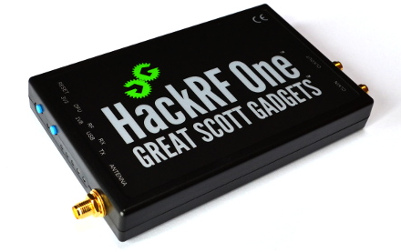
This receiver also has the added advantage of being able to be ‘locked’ to an external 10 MHz reference standard. The importance of this is that the station search algorithms work with FFT bin widths on the order of 1-2 Hz wide and depend on the receiver being able to hold its place to better than that resolution.

This is the area where SETI Net prefers to search.
On the figure this seems to be a very small, limiting area to search – but is it really.

